**Brooklyn torah gazette**

**For parshas behalosecha 5783**

Volume 7, Issue 38 (Whole Number 345) 21 Sivan 5783/ June 10, 2023

**Printed L’illuy nishmas Nechama bas R’ Noach, a”h**

For a free subscription, please forward your request to [***keren18@juno.com***](mailto:keren18@juno.com)

**Prime Minister Netanyahu Eulogizes Haredi Spiritual Leader Rabbi Gershon Edelstein.**

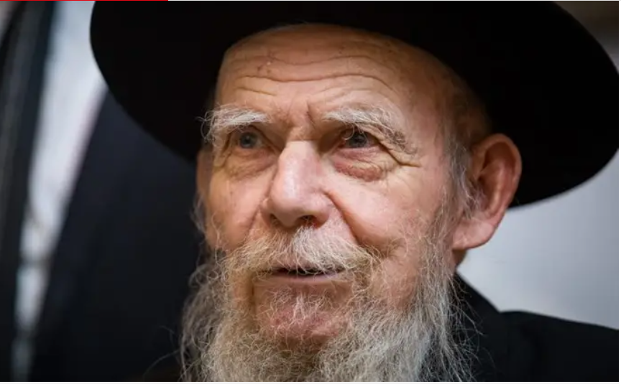

**Photo by Aharon Krohn/Flash90**

Prime Minister Benjamin Netanyahu mourned [the passing](https://www.israelnationalnews.com/news/372101) Tuesday morning of Rabbi Gershon Edelstein, dean of the Ponevezh Yeshiva in Bnei Brak and the spiritual leader of Lithuanian (non-Hasidic) Ashkenazi Jews in Israel.

"Today, the world of Torah, along with the entire people of Israel, has lost a wise and renowned leader – the President of the Council of Torah Sages and head of the Ponevezh Yeshiva, Rabbi Gershon Edelstein, whose entire life was holiness. I mourn his passing and send my most heartfelt condolences to the members of his family."

"Rabbi Edelstein always remembered the days of his youth in Soviet Russia in which he was obliged to study Torah in secret. In contrast to this, here in Israel, he openly spread his wings over the Lithuanian yeshiva world."

"He never took anything for granted. On the contrary, the responsibility for shaping the spiritual image of masses of Jews guided him day and night. Rabbi Edelstein was imbued with love of Israel for everyone. His sensitive attention to the challenges of the generation led him to guide, direct, strengthen and encourage."

"His lessons in Talmud and Jewish law gave expression to his immense diligence. His great persistence will continue to inspire those who listen to his teachings."

"I was fortunate to meet with Rabbi Edelstein several months ago, and the light that shone in his eyes was full of understanding; Jewish wisdom left an indelible mark in him. The importance of instilling the heritage of Israel in the children of Israel sprang from the depths of his soul."

"Rabbi Edelstein passed away a few days after we read in the Torah portion of Naso the opening words: 'Take the sum of the sons of Gershon also, by their fathers' houses, by their families' (Numbers 4:22). His good name will be remembered by everyone – in this generation and in generations to come. May his memory be for a blessing."

*Reprinted from the May 30, 2023 website of Arutz Sheva, Israel National News.*

**Thoughts that Count**

**for Our Parsha**

*At the order of the L-rd the people of Israel journeyed, and at the order of the L-rd they camped* (Num. 9:18)

All of a Jew's actions should be "at the order of the L-rd." Whenever one states a future plan, one should say, "I will do such and such, G-d willing," or "I will do such and such with G-d's help." Likewise, when a person is traveling and reaches his destination, he should declare, "I have come here with the help of G-d." The underlying idea is to always make mention of G-d. (Shaloh)

*Reprinted from the Parshat Beha’alotcha 5760/2000 edition of L’Chaim.*

**The Second Chance for Every Jew Lost on a Distant Journey**

**From the Teachings of the Lubavitcher Rebbe**

**Rabbi Menachem Mendel Schneerson, Zt”l**

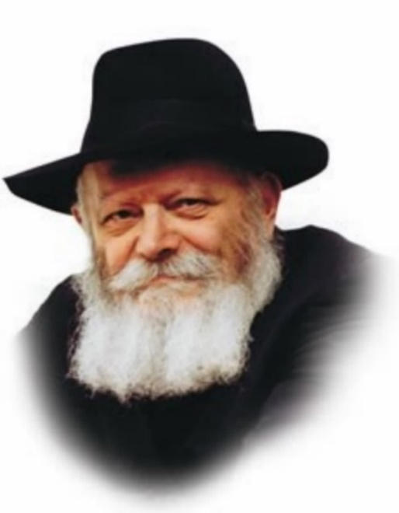

The Torah portion of Beha'alotcha contains the mitzva of Pesach Sheini, the "second Passover." If a person was ritually unclean or "on a distant journey" on the 14th of Nisan, and therefore unable to bring the Pascal offering to the Holy Temple, he is permitted to do so one month later, on the 14th of Iyar.

Our Sages offer several explanations of what is meant by "on a distant journey." One interpretation is that the person was physically unable to reach the Temple courtyard in time for the offering to be slaughtered.

Rashi, however, opines that even one who was standing just outside the courtyard and could have easily entered but chose not to is also considered to have been "on a distant journey." In other words, even though his failure to bring an offering seems to have been deliberate, the Torah allows him a second chance on Pesach Sheini.

The reason is that a distinction is made between a person who deliberately refuses to bring a sacrifice (even though he is present in the courtyard), and one who simply refuses to enter. In the first case, not bringing the Pascal offering is a punishable offense, as it states, "And his soul shall be cut off from his people." In the second instance the Torah is more lenient, and rules that the person's deliberate act consisted of not entering the courtyard, rather than in refusing to offer a sacrifice. If he wasn't in the right place at the right time, he couldn't bring the Pascal offering, and is thus given a second opportunity to do so.

In truth, however, Jewish law allows everyone to make amends, even the person who was present in the courtyard and refused to bring a sacrifice. According to Maimonides, the punishment of excision only applies if he didn't do so one month later, on Pesach Sheini.

Pesach Sheini is thus symbolic of a Jew's ability to rectify all transgressions, even the most deliberate. It is never too late to make amends; a Jew can always correct a past misdeed, and G-d will always be willing to accept him.

This principle also helps us understand the nature of the Final Redemption with Moshiach, whose arrival is imminent. Unlike previous redemptions in Jewish history, when Moshiach comes, not one Jew will be left behind in exile.

Even Jews who don't want to be redeemed will be included with the rest of the Jewish people, as G-d has promised: "And it will come to pass on that day, that the great shofar will be blown, and [even] those who were lost in the land of Assyria will come, and the outcasts in the land of Egypt, and they will worship the L-rd at the holy mount in Jerusalem."

*Reprinted from the Parshat Beha’alotcha 5760/2000 edition of L’Chaim. Adapted from Volume 8 of Likutei Sichot.*

**More Thoughts that**

**Count for Our Parsha**

*And the people of Israel also wept and said: Who shall give us meat to eat?* (Num. 11:4)

In truth, the Jews had plenty of meat to eat in the desert, supplied by the sacrifices that were brought in the Tabernacle; the only restriction was on meat that had not been offered as a sacrifice. The meat of the sacrifices was permitted to be eaten within two days; thus even while traveling the Jews had a two-day supply. It wasn't until the third day of the journey that they began to complain, as they were still in transit and unable to erect the Tabernacle. (Rabbi Shaul of Amsterdam)

*Reprinted from the Parshat Beha’alotcha 5760/2000 edition of L’Chaim.*

**Rav Avigdor Miller on**

**How to Help a Lazy Man**

**Overcome His Nature**

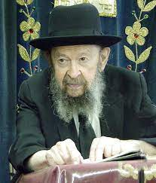

First of all, if he comes late because he goes to sleep late and he gets up late, so the first thing is to go to sleep early. He must get enough sleep. You must get sleep! And after a good night’s sleep, have an alarm clock to wake you up.

Now, in case it doesn’t help, make a neder. Listen to me; make a neder that the first time you’ll come late will cost you $50 for a yeshivah that you don’t like. Just one time. Not forever. Just that the first time you come late you’ll have to make a $50 donation to the yeshivah. You’ll keep on putting off the first time. You’re getting up in the morning for $50. If chas v’shalom you are oiver, so it costs you $50 that week.

Then make another neder. The first time it happens again, another $50. Little by little I guarantee you’ll stop coming late.

*Reprinted from the Parshas Naso 5783 email of Toras Avigdor based on Rabbi Miller’s Tape #E-231 from his classic Thursday night lectures.*

**Rabbi Berel Wein on**

**Parshat B’halotcha 5783**

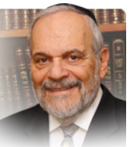

The Torah instructs Aharon and through him all of his successors, the High Priests of Israel, that when lighting the great menorah one should make certain that the six outside lamps should all face into the center lamp. There are various opinions amongst the commentators as to how this was to be accomplished.

The wicks were bent inwards or perhaps the lamps themselves were tilted towards the middle lamp - or it could have been that this was only one of the recurring miracles that defined the Mishkan and later the Temple in Jerusalem. These are just some of the ideas advanced to explain how this matter was in fact accomplished.

The greater question obviously is what lesson is the Torah imparting to us by this instruction that the outside lamps should face the middle lamp. I think that the idea that the Torah wishes us to internalize is that the light of the holy menorah requires focus.

We know that in the physical world the more intense and concentrated the focus of the light, the greater is its ability to illuminate and reveal. Diffused light creates mood and atmosphere but it does not really show what lies before us. The light of the menorah is symbolic of Torah in Jewish life. Torah, its study, support and observance, requires focus and concentration. It cannot serve its true purpose in our lives when it exists amongst us only in a diffused and generalized sense. Our rabbis taught us what the focus of Jewish life is and should be: Torah, G-dly service, human kindness and consideration for others. Other causes are only to be granted - diffused light - and they, by themselves, will not serve to erase the darkness of our existence and society. Every human life, every family, even every educational and commercial enterprise requires focus and concentration in order to be successful and productive.

We all have priorities in our lives. These priorities become the plans, actions and ideas that we focus our attention, talents and resources upon. Judaism demands that we focus upon love and study of Torah and its observances. We should concentrate upon our daily conversation, so to speak – our prayer services – with our Creator.

**Serving G-d Requires Effort, Sacrifice and Devotion**

We are required to serve G-d and do His bidding. And that requires effort, sacrifice and devotion. It is perhaps the most challenging area of our religious life and demands total focus and concentration.  Kindness towards others certainly requires focus. In theory, in a world of diffused light, we all subscribe to the notions of good behavior, social responsibility and charitable ideals.

However, when we are faced with the individual test of performing a specific human kindness to a specific human being we oftentimes shirk that responsibility. Our focus is not present and thus we are prevented, not out of malice but simply out of lack of concentration from performing the necessary act of kindness that lies before us. The lesson of the menorah is one of focus – the focus that will allow the spirit of G-dliness to light our way through our lives.

*Reprinted from the current website of rabbiwein.com*

*\*\*\*\*\*\*\*\*\*\*\*\*\*\*\*\*\*\*\*\*\*\*\*\*\*\*\*\*\*\*\*\*\*\*\*\*\*\*\*\*\*\*\*\*\*\*\*\*\*\*\*\*\*\*\*\*\*\*\*\*\*\*\*\*\*\**

***We remember the fish, which we***

***ate in Egypt for nothing* (Num. 11:5)**

The world was created in such a way that whatever is associated with the "side of holiness" requires hard work and effort. By contrast, the spiritual emanations of the "other side" come easily. In Egypt, a place of moral depravity, the Jewish people had grown accustomed to receiving abundance "for nothing," without any effort on their part. When they left Egypt and realized that they would have to work to receive G-d's blessing, they rose up in protest. (Siddur Im Divrei Elokim Chaim)

*Reprinted from the Parshat Beha’alotcha 5760/2000 edition of L’Chaim.*

**“It’s Not Alright that**

**You Don’t Have a**

**Chair to Sit On!”**

**By Daniel Keren**

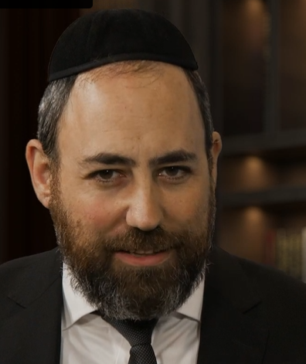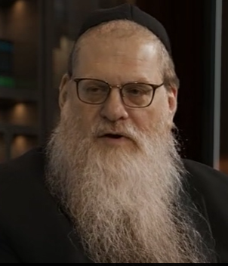

**Rabbi Ron Yitzchok Eisenman (right) being interviewed by Rabbi Yitzchok Hisiger of Inside Artscroll**

We are currently in the fourth season of Inside Artscroll, a fascinating podcast where Rabbi Yitzchok Hisiger gets to interview some of the interesting authors and personalities that interface with perhaps the world’s largest Orthodox Jewish publishing house.

Episode 1 of the current fourth season focused on **Rabbi Ron Yitzchok Eisenman**, the ravof Congregation Ahavas Israel in Passaic, New Jersey, and a renowned speaker and writer. Born and raised in Brooklyn, after marriage he spent years learning in kollel in  Eretz Yisroel and in the States. After teaching Torah as a rebbi in yeshiva for two decades, in 1997 he was appointed as the rav of Ahavas Israel, which today hosts forty minyanim a day beginning at 6 A.M. and continuing to as late as midnight.

In addition to his rabbinic functions, Rabbi Eisenman is a professor at Lander College for Women and has published three books, including the 2018 Artscroll book  **Shul With A View**, which allows the reader to enter the world of a shul rabbi, brimming with unforgettable personalities, joyous events, and sometimes tragic misunderstandings.

I found the 45-minute interview that Rabbi Hisiger conducted with Rabbi Eisenman to be uplifting and it is not surprising that the Passaic Rav is so much in demand as a speaker, He has also been a scholar in residence in Los Angeles, Denver, Cleveland, Memphis, Chicago, St. Louis, West Orange, Staten Island, Lawrence and Brooklyn; while also delivering Torah lectures in Berlin, Leipzig and Frankfurt, Germany; as well as in Vilna, Lithuania and Baku, Azerbaijan. Thousands of Mishpacha readers enjoy his unique and uplifting insights that are published in that popular weekly magazine.

**A Visit to Rav Avrohom Pam, zt”l**

In his recent Inside Artscroll interview, one of the points I found very interesting was Rabbi Eisenman’s recollection of the time he took a group of his students from the Rosenbaum Yeshiva of North Jersey to meet perhaps 30 or 35 years ago one of America’s leading Gedolei Hatorah (Torah scholars,) – Rav Avrohom Pam, zt”l, who at that time was the Rosh Hayeshiva of Mesivta Torah Vodaath in the Kensington section of Brooklyn.

When he called Rav Pam a few weeks in advance to schedule a time when he could bring his students over for the Rosh Hayeshiva to speak with them and offer words of encouragement in their own personal journey to mastering the study of Torah and avodas Hashem (serving Hashem,) Rav Pam wanted to know how many were coming.

Rabbi Eisenman, calculated that he had 12 students, so including himself and one of the administrators, there would be 14 visitors to the Rav’s home. The day of the visit arrived and all 12 students and one of the administrators boarded a special bus that the yeshiva had hired. The bus driver who happened to be religiously observant was surprised when in Brooklyn, his instructions were to go to a strange address in Kensington. He asked where they were going and Rabbi Eisenman informed the driver that they had an appointment to meet with Rav Pam in his home.

The driver asked if he could also come. Rabbi Eisenman said that he couldn’t stop him and so when the bus arrived in front of Rav Pam’s house, the bus driver followed everyone else in entering the Rosh Hayeshiva’s house. Once inside, Rav Pam became somewhat alarmed as he had made arrangement for exactly 15 chairs, 14 for the expected visitors and one for himself. He asked Rabbi Eisenman, “didn’t you tell me that there were 14 people coming?” Embarrassed, Rabbi Eisenman didn’t say a word.

The bus driver realizing what had happened, confessed that he had barged in on his own without being granted permission. He told the Rosh Hayeshiva that as a bus driver he sits all day and its fine if he has to stand.

Looking at the bus driver, Rav Pam, shook his head and simply responded, “No, it’s not alright if you don’t have a chair to sit on.” The Rosh Hayeshiva refused to sit down and fortunately the bus driver spotted a tall coffee table that he was able to sit on, thus allowing Rav Pam to sit down and speak to the boys and give them words of chizuk, inspiration.

Rabbi Eisenman told his host Rabbi Hisiger that this particular incident made a deep impression on him and he would constantly recall that episode, especially at his family’s Pesach seder. Recently, one of his sons who now lives in Israel called him to tell him that a similar incident had just occurred to him and there was not enough seats for everyone, and he offered to stand while the great Torah scholar addressed the group of students that he had brought over. He told his father, that no, he was not comfortable having to stand and now he had an even greater appreciation for the gadlus (spiritual sensitivity) of Rav Pam who had great concern for the dignity of a seemingly simple Jew like the bus driver.

If you would enjoy listening or viewing the entire Inside Artscroll podcast, just google “Season 4 Episode 1 – Rabbi Ron Yitzchok Eisenman.”

*Reprinted from the June 2, 2023 edition of The Jewish Connection.*

**More than Just a Journey**

It was in the second year, in the second month, on the twentieth of the month, the cloud was lifted from upon the Tabernacle of the Testimony. The Children of Yisrael journeyed on their journeys from the Wilderness of Sinai, and the cloud rested in the Wilderness of Paran. They journeyed for the first time at the bidding of Hashem through Moshe (10:11-13).

What does the third pasuk — They journeyed for the first time at the bidding of Hashem through Moshe — add to the earlier pesukim? The Sages observe (Kiddushin 40b) that Torah study is more important than mitzvah performance, “because Torah study leads one to action” — performing mitzvos.

How are we to understand this? A craftsman may study his trade for many years, but no one would suggest that his training is more important than the masterpiece he produces. If the purpose of study is to teach a person how to do the mitzvos, can the preparation be more important than the goal?

Mitzvah performance is fundamentally different than a craft. For it to be truly considered a mitzvah, one must do it because he learned that the Torah commands it; doing something without knowing that it is a mitzvah is not fulfillment of a mitzvah.

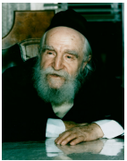

**Rav Moshe Feinstein**

Indeed, Rashi explains the Gemara to mean that when one studies the laws of a mitzvah and then performs it, he has gained both the study and the mitzvah; this implies that without the study, he has neither. Additionally, we are told (Menachos 110a) that, in the absence of the Beis HaMikdash, one who studies the laws of the offerings is considered to have actually brought them.

In this way, Torah study “brings one to perform mitzvos” — for through his study, he is rewarded as if he had actually performed the mitzvah. The third pasuk here is teaching us that the Jews did not merely travel. They moved at the bidding of Hashem through Moshe. Because Hashem had commanded it, they were fulfilling His will.

*Reprinted from the Parshas Behalosecha 5782 edition of At the ArtSroll Shabbos Table. Excerpted from the ArtScroll book Kol Rom - Rav Moshe On Chumash – Volume 2 from Rav Moshe Feinstein zt”l, compiled by Rabbi Avraham Shlomo Fishelis, adapted by Rabbi Avrohom Biderman*

Change Someone's Life

**Change Someone’s Life**

**By Rabbi Zecharia Wallerstein zt"l**



All the struggles we go through in life cause us hardship and heartache. There is no question about that, and no difficulty should ever be minimized. And yet with it, we must also recognize the place that leaves us and the responsibility that charges us with. Having gone through that struggle, you can help others.

There’s a reason you went through it, which may not be apparent to you and may never be known to you. However, one thing you do know is that with it, you can help others. You can be a living role model, through your actions and discussions with them.

Don’t turn away. Don’t say that you don’t have anything to offer. However big or small, you have something to help others with. Step out of your zone into someone else’s world and help change their life.

This is no hyperbole. You can change someone’s life by using your struggle to help them and be there for them. Do it. Today… tonight. Don’t wait. Don’t wait to touch the heart of someone else and change their life and their future. Because you really can.

*Reprinted from the Parshat Bechalotcha 5782 edition of the TorahAnyTimes Newsletter at compiled and edited by Elan Perchik.*

***And the man Moses was very humble, more so than anyone on the face of the earth* (Num. 12:3)**

The reason for Moses' humility was that he had attained the ultimate spiritual level of chochma, wisdom. For the greater a person's understanding and comprehension of G-d, the more it will cause him to feel completely nullified before Him. This humility will then be reflected in his relationship with human beings. (Likutei Torah)

*Reprinted from the Parshat Beha’alotcha 5760/2000 edition of L’Chaim.*

**The Rabbi and the Business Man on the Airplane Flight**

**By Rabbi David Bibi**

Rabbi Shlomo Landau tells a story: He boarded a plane and it was very full, but he found himself with an empty seat next to him and they were about to close the plane doors. He thought to himself how lucky he was, and all of a sudden, a well-dressed guy runs onto the plane and takes that seat.

The Rabbi already had his sefer open to learn, and as the man sits down, he introduced himself. He was the head of a large company and they were both headed to the same city.

The business man was going to check on a new office they just opened that wasn’t doing as well as it could be doing. He complained that they were really struggling to find good people. And he continued, “But if I was Jewish, I wouldn’t be struggling to find good people!”

The Rabbi asked, “what do you mean”?

The man continued: “Even though I knew nothing about the city where we’ve opened this branch, that’s because I’m a non-Jew, but if I were Jewish, I would tap into the local Jewish community and they would connect me; they would help me find good people and they would support me. I know that had I had the connections you have and people I could trust to advise and help me, I am sure it would have been a success from the beginning.”

Wow!

So, the Rabbi asks the man where he comes from. He told him Salt Lake City.

And I found that even more amazing. He wasn’t from Brooklyn or Monsey or Boca or Surfside, he was from a place with one Chabad rabbi, where it’s a struggle to even get a minyan. With hardly any Jews in his life, this man knew that Jewish people help each other.

Consider this: Word on the street is that Jewish people are there for each other and they take care of each other. This is the highest level of kiddush Hashem – of sanctification of Hashem’s name and I see it in the community business chats where people go out of their way to help each other. Where competitors share the names of buyers and advise on experts and business practice and on credit worthiness.

And why is that?

I would venture to guess that deep down, we really understand that Hashem is the source of all blessings. Even if we forget it for a minute here or there. Even if our yeser hara pushes us to think that it’s all about me, at the end of the day we remember and we know and we’ve seen time and again, that Hashem runs the world. And with that knowledge there is nothing to stop us from being there for each other.

Now I wish it was really as good as this executive from Salt Lake City imagines we you know that sometimes it is, but it’s really something for us to strive for. Kol Yisrael Arevim Zeh LaZeh.

*Reprinted from the Parashat Naso 5783 email of Rabbi David Bibi’s Shabbat Shalom from Cyberspace.*